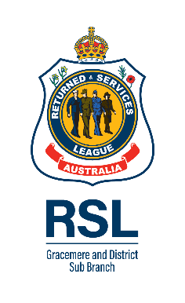
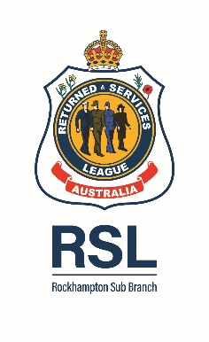
cordially invite
Members and Partners
ROCKHAMPTON HIGHLANDERS PIPE BAND
to attend a Combined Services Dinner
to remember the 110th Anniversary of the Battle of Pozieres

DATE/TIME: Sunday 13th September 2026 @ 1730h
LOCATION: Frenchville Sports Club
DRESS: Dinner Jacket, tie, full decorations & miniature medals;
Ladies After 5 wear (medals if applicable)
RSVP: Monday 31 Aug 2026 with any dietary requirements to
helen.dundas-taylor@rockhampton.rslqld.net.au or 0419540747
DONATION: Payment by 31 Aug of $10pp by group into
BSB: 813049 Account Name: Combined Service Dinner
A/c No: 100109524 Reference: CQMM Donation – Rockhampton Pipe Band

